Hand-in 1

Exercise 1:
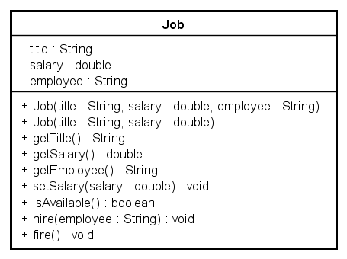
Create a new Java Project in Eclipse and name it Hand-in 1a.
Create the class Job such that you implement:
- three instance variables, a job title, a monthly salary and an employee, name them title, salary and employee where title should be of type String, salary of type double and employee of type String.
- a 3-argument constructor setting all three instance variables
- a 2-argument constructor with job title and salary as argument. Set the employee to null.
- getters for all instance variables
- A method setSalary setting the salary
- A method isAvailable returning true if no employees are set (if employee is null) otherwise returning false.
- A method hire (a set method for employee) setting the employee given as argument to the employee of the job – but only if the job is available, if not available then nothing is set.
- A method fire removing the employee of the job (setting it to null).

Create a test class for class Job and name it JobTest

Exercise 2:
Create a new Java Project in Eclipse and name it Hand-in 1b.
Write a program with a main method in which you read 3 integers from keyboard:
a day, a month and a year, representing a date.
Print out the date as a string separated by “/” for example, if day=2, month=9, year=2014 the output will be printed as “2/9/2014”
If the input represents an illegal date then print out “Illegal date” instead. For example if day=32, month=9, year=2014, the output will be “Illegal date”.
An illegal date is a month less than or equal to 0 or larger than 12 and a day less than or equal to 0 and larger than the maximum number of days in the specific month (February has 28 days, April, June, September and November all have 30 days and the rest have 31 days)
Ignore leap years and treat 29th of February as an illegal date too.

Create a single class where you implement and test this, and name it MonthTest

Exercise 3:
Create a new Java Project in Eclipse and name it Hand-in 1c.
Create a class called MyDate that represents a date including three pieces of information as instance variables, a month (type int), a day (type int) and a year (type int).

- Your class should have a constructor that initializes the three instance variables and assumes that the values provided are correct.
- Provide a get method for each instance variable.
- Provide a void method set(int day, int month, int year) that sets/changes all three instance variables with the values given as arguments.
Use the logic from Exercise 3, so that only valid input will be given to the instance variables. When the input is an illegal date, set the values to 1/1/2000.
(Challenge): Only change illegal parts of input, and use min or max values. For example, if day = 32, month = 9 and year = 2014, set month and year to the input, but set day to 30 (maximum number of days in month 9).
- (Challenge): Rewrite the constructor from a) so that it calls the set-method instead of setting the values directly.
- Provide a method toString() that returns a string with the date information i.e. the day, month and year separated by forward slashes (/). Example: 23 January 1996 (release date for the first Java version) will be returned as "23/1/1996"

Write a test application named MyDateTest that demonstrates class MyDate's capabilities.
Let the user input numbers for day, month and year, and use these to create at least one MyDate object.

The solution must be handed in as 5 separate .java files.
Everything must be handed in before the end of class.

